

E-Commerce Web Application

Software Design Specification

Version: 1.0

Date Created: 04/06/2019

Preface

This document presents the Software Design Specification for E-commerce web application Software by Mawai Infotech LTD. The major sections of the document address the system decomposition by module, concurrent process, and data entity. The system dependencies are also described.

Section 2, Decomposition Description, gives a view of the whole system design including concurrent processes and data entities that are common amongst all system modules. This section will also describe the dependency and accessibility of a section from another. This discussion includes a UML Class Diagram that depicts the entire system.

Section 3, Dependency Description covers the view of the dependent modules and how they will function parallel with each other. All the modular dependencies are defined and operational flow is depicted through DFDs of the respective modules.

Section 4, Interface Description, goes into detail about the user interface for each module of the E-commerce web application System. This is followed by an important discussion of the processes implemented in logic for each module of the system.

Section 5, Detailed Design, extends the design discussion found in Section 2 and describes the design for each system module in more detail. Diagrams are included for each module design discussion. This is followed by a description of the data requirements for each module and the design of those data elements.

Table of Contents

1 Introduction 1

1.1 Purpose 1

1.2 Scope 1

1.3 Definitions and Acronyms 1

1.4 References 1

2 Decomposition Description 2

2.1 Module Decomposition 2

2.2 Concurrent Process Decomposition 2

2.3 Data Decomposition 2

3 Dependency Description 3

3.1 Inter-module Dependencies 3

3.1.1 Independent Modules 3

3.1.2 Dependent Modules 3

3.2 Data Dependencies 4

3.2.1 Customer’s modules 4

3.2.2 Vendor’s modules 8

3.2.3 Administrator modules 10

4 Interface Description 15

4.1 Module Interface 15

4.1.1 Registration Module 15

4.1.2 Login Module 16

4.1.3 Navigation bar (Before Login) 16

4.1.4 Navigation Bar (After login) 17

4.1.5 Customer Menus 17

4.1.6 Landing Page 18

4.1.7 Categories Display 19

4.1.8 Subcategories Display 19

4.1.9 Filtering by brands 20

4.1.10 Products Display page 21

4.1.11 Product description display 21

4.1.12 Customer’s Cart 22

4.1.13 Payment Page 22

4.1.14 Previous orders details 23

4.1.15 Order Receipts viewing 24

4.1.16 Expanded invoice details 24

4.1.17 Vendor Dashboard 25

4.1.18 Vendor Sidebar 26

4.1.19 Adding products in bulk 26

4.1.20 Individual entry for adding products 27

4.1.21 Edit/Delete products 28

4.1.22 Product update form 28

4.1.23 Add images of incomplete entries 29

4.1.24 Viewing order receipts 29

4.1.25 Expanded Order receipts 30

4.1.26 Viewing all categories 31

4.1.27 Viewing all subcategories 31

4.1.28 Adding main category 32

4.1.29 Adding subcategories 32

4.1.30 User management page 33

4.1.31 Add new user form 33

4.1.32 Edit Details 34

4.1.33 User selection 34

4.1.34 Adding privileges 35

4.1.35 Delete privileges 35

4.1.36 Viewing transactions 36

4.1.37 Expanded invoice details 36

4.1.38 Invoices of particular user 37

5 Detailed Design 38

5.1 Login/Signup Module 38

5.1.1 Design 38

5.1.2 Design Description 38

5.2 Purchasing products 38

5.2.1 Design 38

5.2.2 Design Description 39

5.3 Login/Signup Module 39

5.3.1 Design 39

5.3.2 Design Description 39

5.4 Login/Signup Module 39

5.4.1 Design 39

5.4.2 Design Description 39

5.5 Login/Signup Module 40

5.5.1 Design 40

5.5.2 Design Description 40

5.6 Login/Signup Module 40

5.6.1 Design 40

5.6.2 Design Description 40

5.7 Login/Signup Module 40

5.7.1 Design 40

5.7.2 Design Description 41

5.8 Login/Signup Module 41

5.8.1 Design 41

5.8.2 Design Description 41

5.9 Login/Signup Module 41

5.9.1 Design 41

5.9.2 Design Description 42

Appendix A – E-commerce web application class diagram 43

**Table of Figures**

Figure 1: Signup module DFD 4

Figure 2: Login Module DFD 5

Figure 3: View products DFD 5

Figure 4: Place order DFD 6

Figure 5: Update Product Details DFD 6

Figure 6: Purchase items and payment process DFD 7

Figure 7: View Invoice Details DFD 7

Figure 8: Add products DFD 8

Figure 9: Update Product details DFD 8

Figure 10: Delete product DFD 9

Figure 11: View Orders DFD 9

Figure 12: Add category DFD 10

Figure 13: Add subcategories DFD 10

Figure 14: Adding Privileges DFD 11

Figure 15: Update Privileges DFD 11

Figure 16: Remove privileges DFD 12

Figure 17: Adding new user DFD 12

Figure 18: Update user details DFD 13

Figure 19: Remove User DFD 13

Figure 20: Viewing transaction module DFD 14

Figure 21: Signup UI diagram 15

Figure 22: Login UI diagram 16

Figure 23: Navigation Bar (Before Login) UI Diagram 16

Figure 24: Navigation Bar (After Login) UI Diagram 17

Figure 25: Customer Menus UI diagram - (i) 17

Figure 26: Customer Menus UI diagram - (ii) 17

Figure 27: Landing Page UI Diagram - (i) 18

Figure 28: Landing page UI Diagram - (ii) 18

Figure 29: Categories dropdown UI Diagram 19

Figure 30: Subcategories UI diagram 19

Figure 31: Filtering by brands UI diagram 20

Figure 32: Products display page UI diagram 21

Figure 33: Product description UI diagram 21

Figure 34: Customer cart UI diagram 22

Figure 35: Payment page UI Diagram 22

Figure 36: Previous orders details UI diagram 23

Figure 37: Order receipts UI Diagram 24

Figure 38: Expanded payment details UI Diagram 24

Figure 39: Vendor Dashboard UI diagram 25

Figure 40: Vendor Sidebar UI diagram 26

Figure 41: Products' bulk entry UI diagram 26

Figure 42: Individual entry of products UI diagram 27

Figure 43: Edit/Update product UI diagram 28

Figure 44: Product Update form UI diagram 28

Figure 45: Updating product images 29

Figure 46: Order receipt 29

Figure 47: Expanded Order receipt 30

Figure 48: View all categories UI diagram 31

Figure 49: Viewing all subcategories UI diagram 31

Figure 50: Adding main category 32

Figure 51: Adding subcategories UI diagram 32

Figure 52: User management UI diagram 33

Figure 53: Add new user UI diagram 33

Figure 54: Edit User details UI diagram 34

Figure 55: User Selection UI diagram 34

Figure 56: Adding privileges UI diagram 35

Figure 57: Removing privileges for vendor UI diagram 35

Figure 58: Transactions view 36

Figure 59: Expanded invoice details UI diagram 36

Figure 60: Individual Invoices UI diagram 37

Figure 61: Login/Signup Class description 38

Figure 62: Products Purchase Class description 38

Figure 63: Login/Signup Class description 39

Figure 64: Login/Signup Class description 39

Figure 65: Login/Signup Class description 40

Figure 66: Login/Signup Class description 40

Figure 67: Login/Signup Class description 41

Figure 68: Login/Signup Class description 41

Figure 69: Login/Signup Class description 42

**List of tables**

Table 1: Definitions, Acronyms and abbreviations 1

Table 2: References 1

# Introduction

## Purpose

The purpose of the Software Design Specification is to describe the specific design of the E-commerce web application software by Mawai Infotech LTD. The design specification includes an overview of the design along with software module decomposition.

This document provides a detailed description of each software module’s design. For each module, a user interface design and class diagram design is given. As well, a process description is described for each module. It is in the process description that the details of what logic will need to be implemented are given.

## Scope

It is within the scope of the Software Design Specification to describe the specific system design of the E-commerce web application project. This would include user interface design, object-oriented class design, process design, and data design. Any specific detail that is needed about the standards or technology used to design the software are within the scope of this document.

It is outside the scope of this document to describe the need of E-commerce web application software and also its advantages and need for a particular part of work. It is also outside the scope of this document to describe in any detail at all how certain mentioned standards or technologies work and operate.

## Definitions and Acronyms

Table 1: Definitions, Acronyms and abbreviations

|  |  |
| --- | --- |
| **Definition, Acronym, or Abbreviation** | **Description** |
| SDS | Software Design Specification. |
| DB | Database |
| SQL | Structured Query Language |

## References

Table 2: References

|  |  |
| --- | --- |
| **References** | **Description** |
| Project planning Document | The project planning document of E-commerce web application System which has been made first was referenced. |
| Software Requirements Specification | The Software Requirements Specification from the E-commerce web application project was referenced. |

# Decomposition Description

## Module Decomposition

The E-commerce web application software is decomposed into following modules:

* Login/Signup module
* Buying products
* Viewing products in cart
* Modifying products in cart
* Payment process
* E-mail and message confirmation
* Viewing and print order receipts
* Adding products to database
* Modifying products details
* Deleting products from database
* Viewing and printing orders information
* Adding categories and subcategories
* Adding users to database
* Editing user details.
* Removing users from database.
* Adding privileges of the user.
* View and print transaction details.

## Concurrent Process Decomposition

The E-commerce web application software consists of following concurrent processes –

* **Buying products and generation of order receipt –** These processes will be initiated when a customer will buy products. After the customer has finalized the products he wants to purchase, then he will proceed to pay and after that, automatically, the order receipt will be generated. The summary of the order will also be sent through a message on the phone number provided by him.
* **Adding products in bulk and displaying incomplete entries –** These processes are concurrent as first, if the vendor add products in bulk, he/she cannot upload the images of the products, so the form of completing the incomplete entries will be opened and all the products which are added via the excel sheet are displayed. Then, vendor upload the images of the products, and then the images will be displayed at the customer side while buying the items.

## Data Decomposition

Following are the major data components –

* **Login Information –** This data component will be stored in order to allow the users to access the application and perform the necessary task. This information is private and will be kept secured. This information will be entered by the user at time of logging in to the application for product purchase, and by vendor at the time of product management.
* **Products Information –** This data component will be stored in order to allow customers to view items. The customer will log in to the application and when he will select the category, then, the products details will be displayed to him.
* **Order information –** This data component will be used in order to store the details of the products, that user has bought. This information will be used by the vendor to deliver the products to the customer. The order details will contain all the information of the product along with the quantity ordered by the customer.
* **Transaction Details –** This data component is stored to allow the administrator to view all transaction on the application. In case, there is a problem between customer and vendor regarding transaction, administrator can look up to the details and proceed with action.

# Dependency Description

## Inter-module Dependencies

### Independent Modules

The following modules are independent and do not rely on any other modules to initiate them or to provide data.

* Login/Signup module
* Viewing products in cart
* Buying products
* Modifying products in cart
* Viewing and print order receipts
* Adding products to database
* Modifying products details
* Deleting products from database
* Viewing and printing orders information
* Adding categories and subcategories
* Adding users to database
* Editing user details.
* Removing users from database.
* Adding privileges of the user.

### Dependent Modules

The following modules are dependent on one another for their functioning.

* Payment process – This module is dependent on buying products module, as payment process is initiated once the user has confirmed the order. After order confirmation only, the payment process should be done, so, the amount to be paid is received from the buying products module and then forwarded to the payment gateway service for process.
* Email and message confirmation – This module is dependent on payment process module. After successful payment only, the user should receive mail and message stating that the order has been confirmed. As, the message will contain information about the products ordered and bill amount, so it has to be processed after successful order placement.
* Viewing and printing transaction details – This is a module of administrator, but it is dependent on the customer module of purchasing item because, the transaction receipt is generated once the payment on the customer side is successful. After that, the transaction details are sent to customer’s mail id and mobile number. The same transaction receipt can be viewed on the administrator side after that. So, this module is dependent on purchasing item and payment process module.

## Data Dependencies

The following Data Flow Diagrams shows the data dependencies between various components of the system and database. Each module has its own data dependencies which are represented module-wise below –

### Customer’s modules

1. Sign up module

Figure 1: Signup module DFD

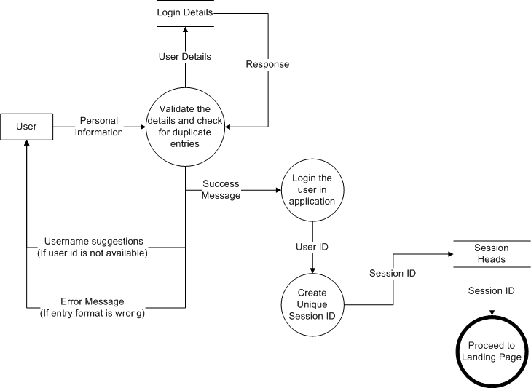

1. Login module

Figure 2: Login Module DFD

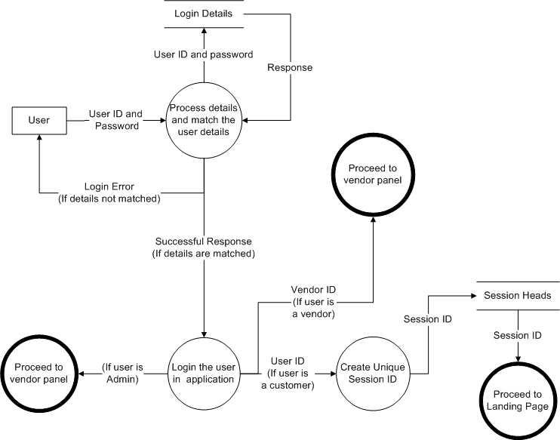

1. View products module

Figure 3: View products DFD

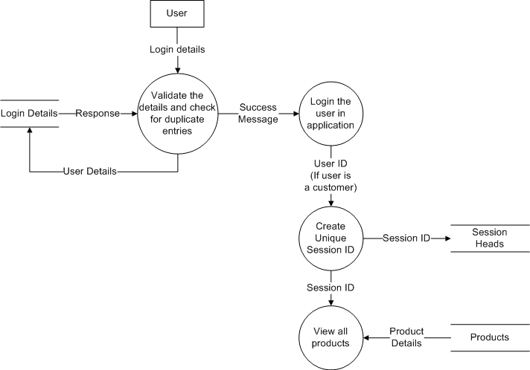

1. Place order module

Figure 4: Place order DFD

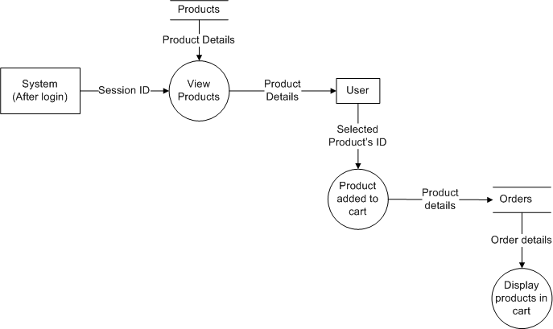

1. Modify order module

Figure 5: Update Product Details DFD

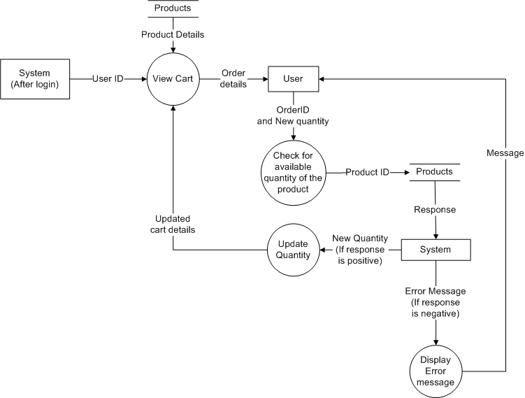

1. Purchasing items and payment process

Figure 6: Purchase items and payment process DFD

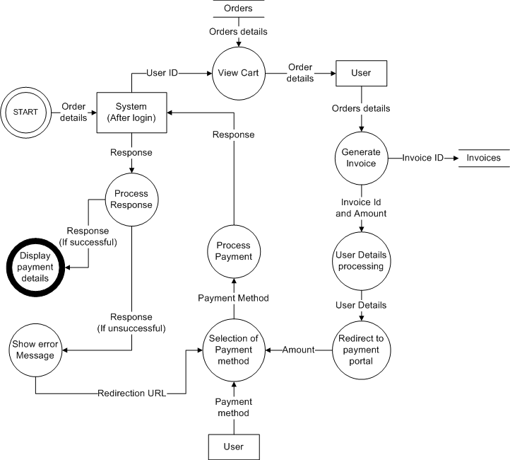

1. Viewing order receipts

Figure 7: View Invoice Details DFD

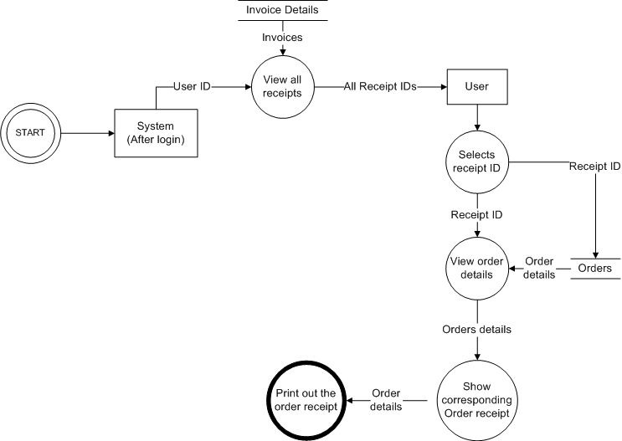

### Vendor’s modules

1. Adding products module

Figure 8: Add products DFD

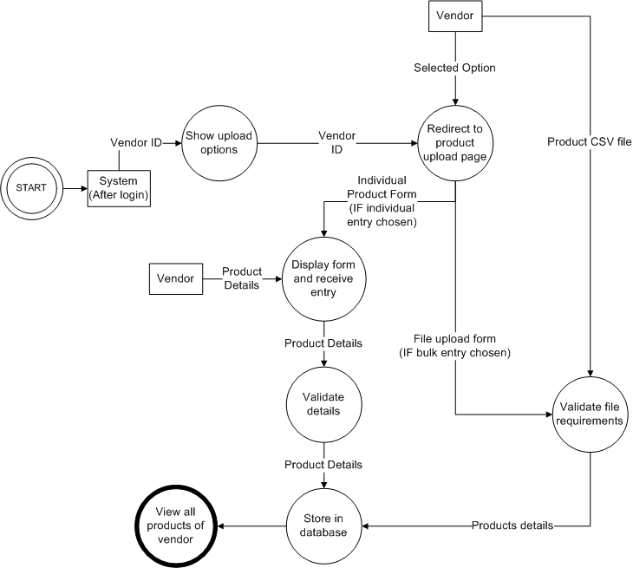

1. Update Product details module

Figure 9: Update Product details DFD

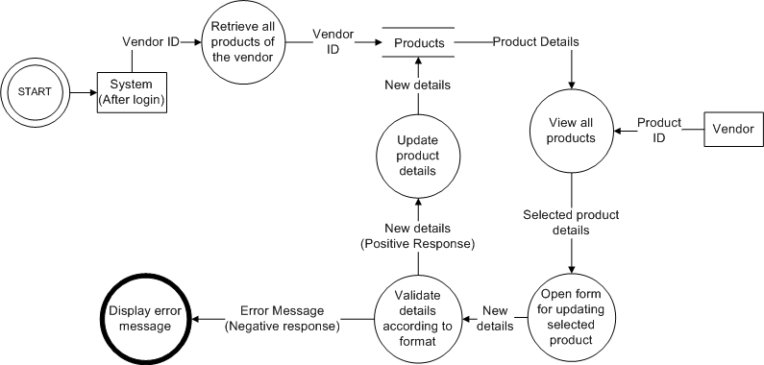

1. Deleting product module

Figure 10: Delete product DFD

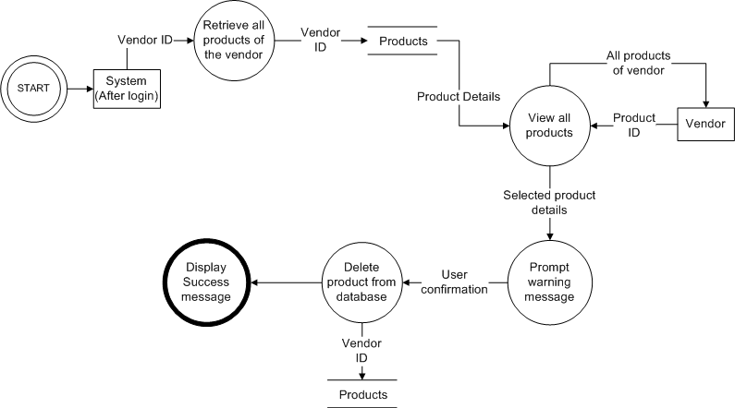

1. Viewing Orders module

Figure 11: View Orders DFD

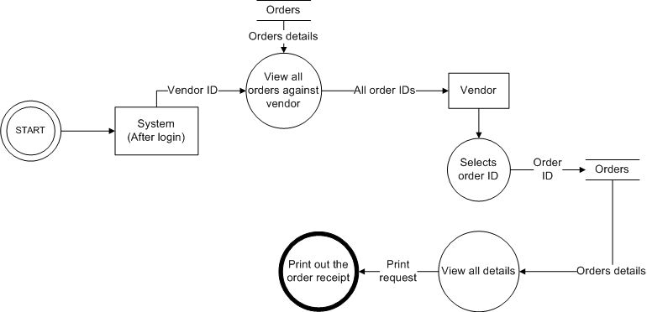

### Administrator modules

1. Adding categories module

Figure 12: Add category DFD

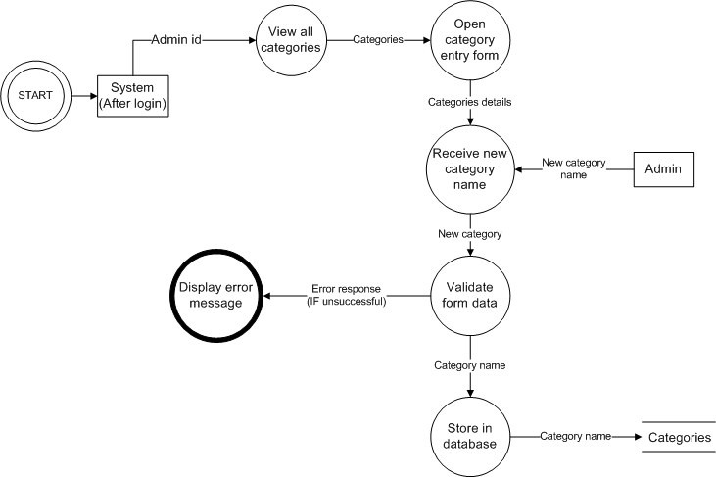

1. Adding subcategories module

Figure 13: Add subcategories DFD

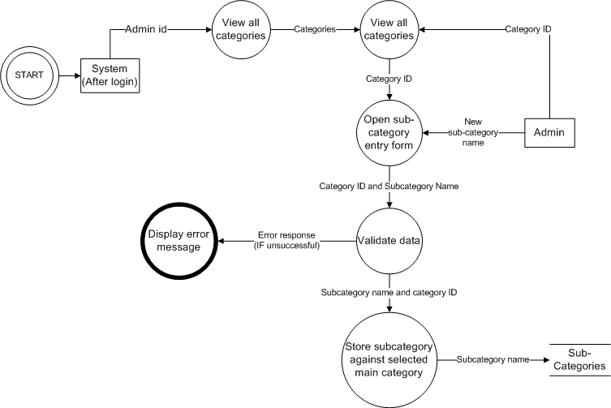

1. Adding privileges module

Figure 14: Adding Privileges DFD

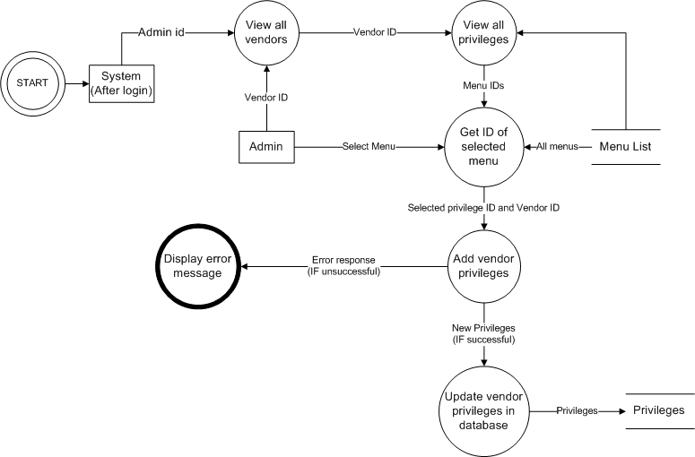

1. Updating privileges module

Figure 15: Update Privileges DFD

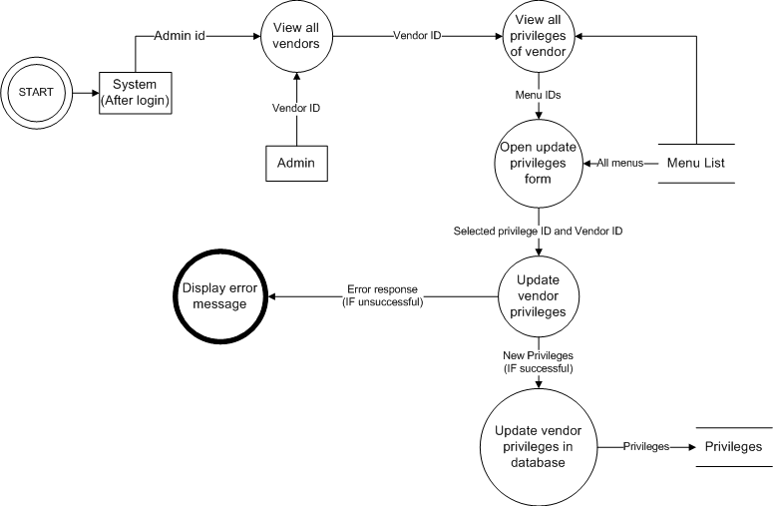

1. Deleting privileges module

Figure 16: Remove privileges DFD

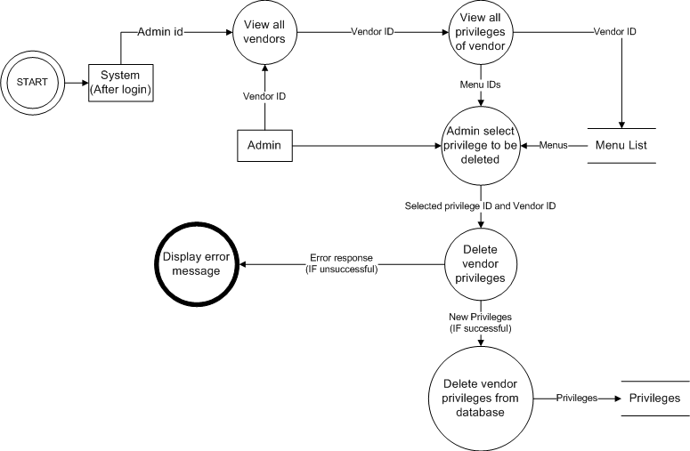

1. Adding new user module

Figure 17: Adding new user DFD

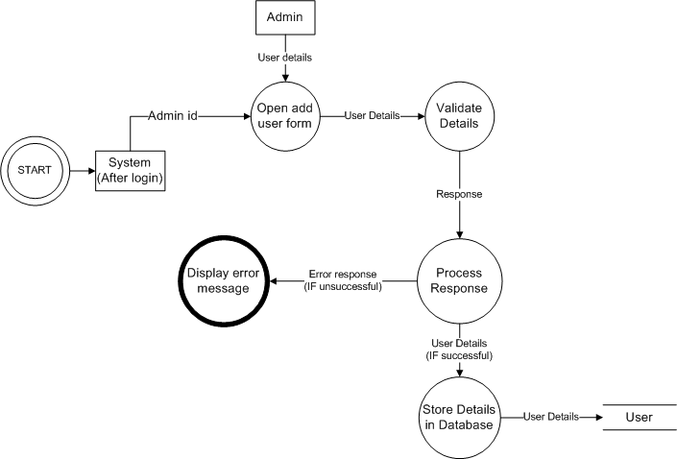

1. Updating user details module

Figure 18: Update user details DFD

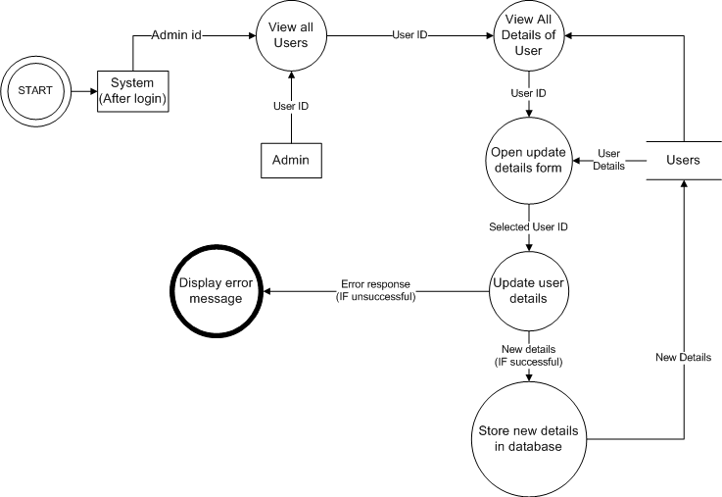

1. Removing user module

Figure 19: Remove User DFD

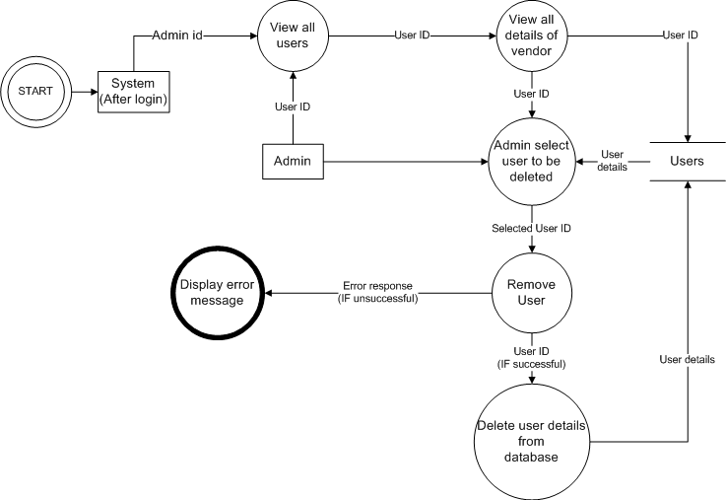

1. Viewing transaction module

Figure 20: Viewing transaction module DFD

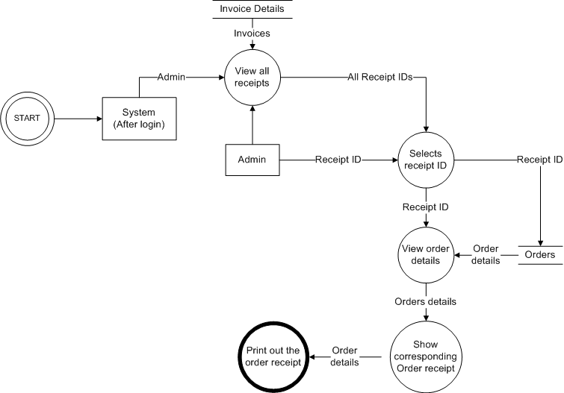

# Interface Description

## Module Interface

### Registration Module

#### User Interface Design

Figure 21: Signup UI diagram

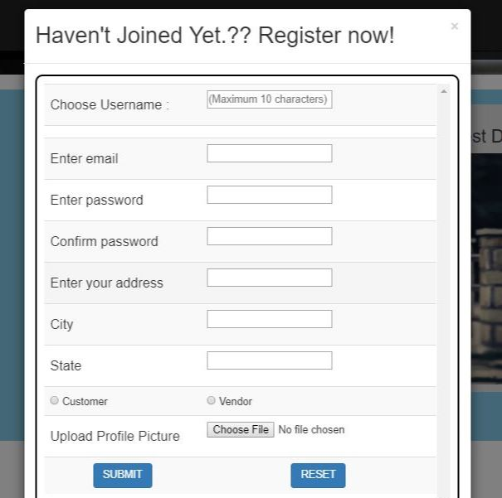

#### Description

This above UI form shows the signup page, which, the user has to fill for registering in the application. After registration, user will have the access to the features of the application such as viewing products, adding products to cart, etc. But the condition will be that, the username should be unique, otherwise there are chances of failure login and database error. After successfully meeting all the requirements, the user can login into the system using the same username and password.

### Login Module

#### User Interface Design

Figure 22: Login UI diagram

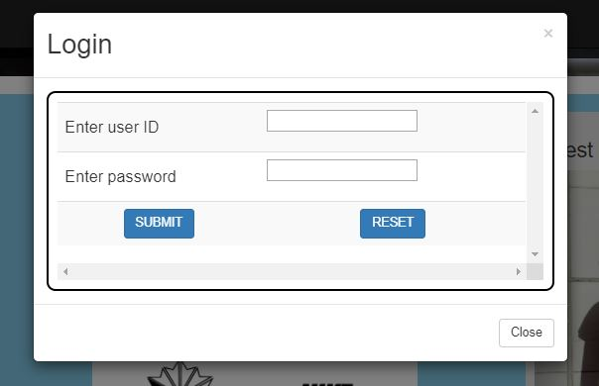

#### Description

This User Interface shows, how the user has to login into the system using his username and password. The username and password was set by the user before. After logging in to the system, the user will be able to perform the desired operations, which he wants to. The user details will be matched here in the backend, an after validation, the user will be redirected to the page. Otherwise, the error will be shown and user has to try again until he enters the right combination of username and password.

### Navigation bar (Before Login)

#### User Interface Design

Figure 23: Navigation Bar (Before Login) UI Diagram



#### Description

This User Interface shows, the navigation bar, which will appear on the top of the page and will contain all the menus available for the user. This is the navigation bar before login. In this, only signup and logion button will be displayed and other menus will be displayed once the user has signed up or logged in.

### Navigation Bar (After login)

#### User Interface Design

Figure 24: Navigation Bar (After Login) UI Diagram



#### Description

This is the navigation bar after login. In this, all the functions of the customer will be displayed and he can move to any of the modules by clicking the respective button.

### Customer Menus

#### User Interface Design

Figure 25: Customer Menus UI diagram - (i)



Figure 26: Customer Menus UI diagram - (ii)



#### Description

There will be categories menu, in which user will get a dropdown, in which he/she can select the main category of the product, he/she wants to purchase. There will be another functions available for the customer. The functions will be – Invoice details (To view the order receipts), Go to cart (To view the items added to cart), Previous Orders (To view the items ordered previously), Logout (To Sign out of the application and go to landing page).

### Landing Page

#### User Interface Design

Figure 27: Landing Page UI Diagram - (i)



Figure 28: Landing page UI Diagram - (ii)



#### Description

This User Interface shows the landing page (First page of the application) that user will see once he has opened the application. There he will see the random products images, offers on the products, etc. Also, at the end, there will a contact section, where the contact information of the company will be given along with a map, indicating the location of the company. After that, a footer will be there, in which copyright information will be present. This page will have no functionality, and only front end display part will be there.

### Categories Display

#### User Interface Design

Figure 29: Categories dropdown UI Diagram



#### Description

This User Interface diagram shows the expanded body of category tab as in **Figure 25****.** There will be various categories added by the administrator. These categories will appear in this dropdown and after selecting one of these main categories, the user will go to the products display page and then select the filter, he wants to apply for selecting the products.

### Subcategories Display

#### User Interface Design

Figure 30: Subcategories UI diagram

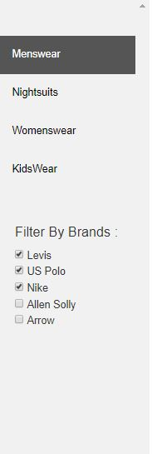

#### Description

This User Interface shows the subcategories under the main category that user will select from the categories dropdown. After clicking any subcategory, the user will see only those products, which are stored in database under the selected sub-category. This menu will be displayed in the left side bar of the page. The sidebar will be permanent. Only the subcategories and brands will change, according to the categories.

### Filtering by brands

#### User Interface Design

Figure 31: Filtering by brands UI diagram

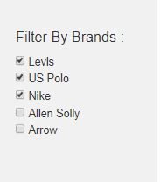

#### Description

This User Interface shows the filtering module, in which user can choose the brands of the products, which he wants to purchase. In this way, the products can be more specifically shown to hum and help him to make his choice more clearly. The brands name will be in form of checkboxes, in which whenever, user selects another brand, the products under that brand should be added to display. The user will only select the checkboxes, without any submit button, and then the products will be added. If no checkboxes are selected, then all the brands products should be displayed. The brands should be taken from database, so that, each brand will have at least one product to display.

### Products Display page

#### User Interface Design

Figure 32: Products display page UI diagram

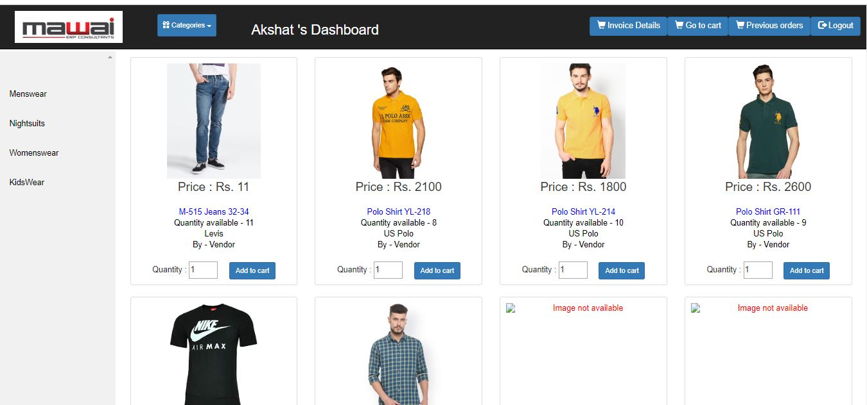

#### Description

This UI diagram shows, how the customer will view the products he has chosen. All the products after filtration by categories, subcategories and brands will be displayed here and user will view the products. The products whose images are not uploaded by the vendor, shall not be displayed and instead, a message should be displayed, “Image not available”.

### Product description display

#### User Interface Design

Figure 33: Product description UI diagram

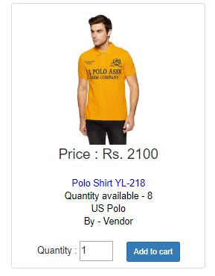

#### Description

This User Interface shows, how the product description will be displayed to the customer. The description should contain – product price, product name, product quantity available, product brand, and seller’s name. After that, there will be one quantity input box, in which user will enter the quantity of the product he wants to buy. After that, there will be a button, on the click of which, the order will be validated, and then added to cart.

### Customer’s Cart

#### User Interface Design

Figure 34: Customer cart UI diagram

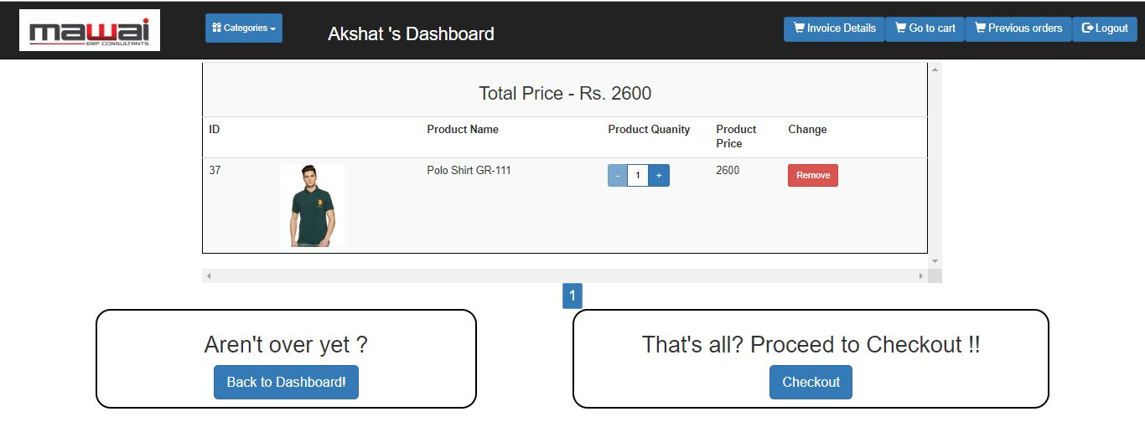

#### Description

This User Interface shows the customer’s cart in which products will be displayed after the customer has added them. There will be product details along with the button of ‘+’ and ‘-’ by which user can increase or decrease quantity and the price will change according to that. There will be remove button, which will remove the product from customer’s cart. There will be checkout button, and on clicking that button, the user will be redirected to the payment page.

### Payment Page

#### User Interface Design

Figure 35: Payment page UI Diagram

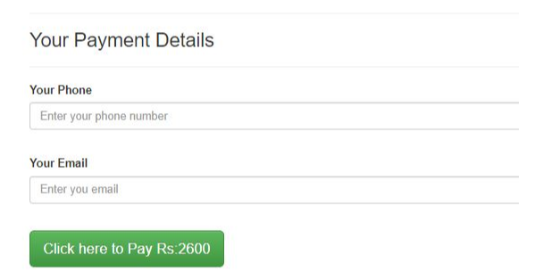

#### Description

This User Interface diagram shows the form that user will fill after he has confirmed the order in the cart. The price will appear on the button as “Click here to pay Rs. XXXX”. In the field, user will enter the phone number and email address. That email address and phone number will be used for sending conformation message

### Previous orders details

#### User Interface Design

Figure 36: Previous orders details UI diagram

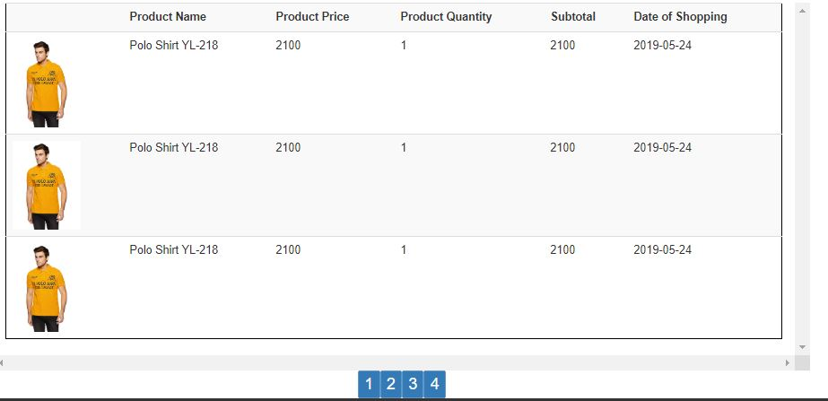

#### Description

This User Interface shows the screen on which all the previous orders of the customer will be displayed. The details will contain all the product details, along with the quantity of the product ordered and date of purchase. Subtotal of the amount paid against each product should be displayed. At the bottom, the page numbers will be displayed and each page will have at most items to be displayed. This will help to view the products more easily. The order details will be automatically sorted in order of descending date of placing the order.

### Order Receipts viewing

#### User Interface Design

Figure 37: Order receipts UI Diagram

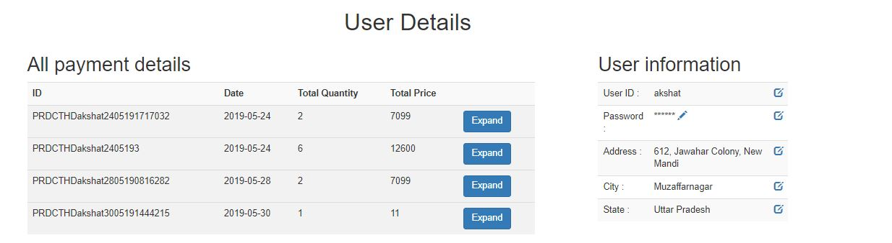

#### Description

This User Interface shows how the order receipts summary will be displayed. The customer can view all the invoices and expand them to view the details of the orders. On the right hand, the user information will be displayed in which he can view his details and edit them.

### Expanded invoice details

#### User Interface Design

Figure 38: Expanded payment details UI Diagram

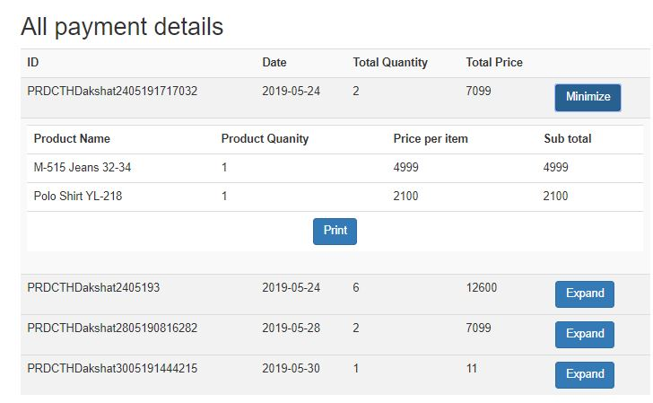

#### Description

This User Interface shows how the details will be displayed after the user has clicked the expand button of a particular order receipt. In the details, the product name, quantity, price and subtotal should be displayed. There will be a print button below, and if we click that, then the order details of that particular receipt will be printed.

### Vendor Dashboard

#### User Interface Design

Figure 39: Vendor Dashboard UI diagram

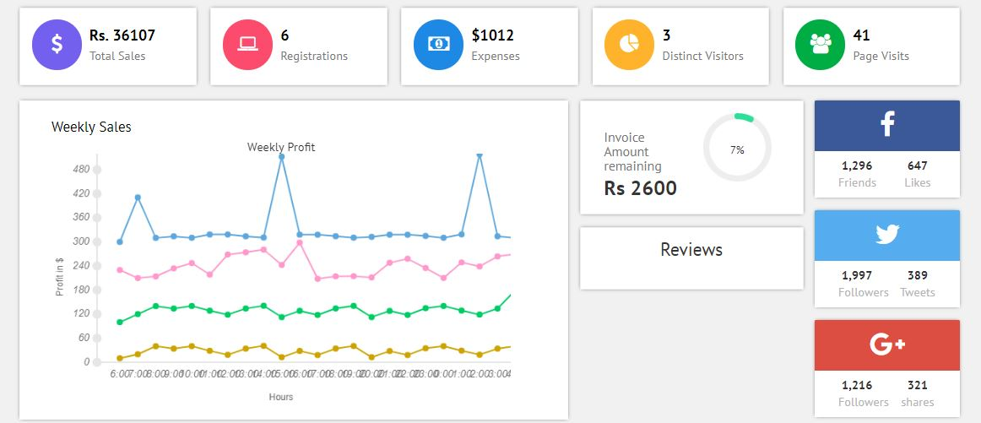

#### Description

This User Interface shows, the vendor landing page after login. On this page, the vendor will be able to view the number of visitors, total invoice amount remaining to be paid by the customer (i.e. the total price of products added in cart but not yet purchased), Facebook reviews and Google analytics.

### Vendor Sidebar

#### User Interface Design

Figure 40: Vendor Sidebar UI diagram

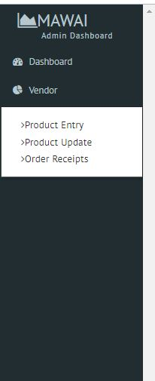

#### Description

This User Interface shows the menus/privileges of the vendor given by administrator. The vendor can use any functionalities of the menu listed in the sidebar. There may be sub-menus inside main menu, so that will be displayed in form of hover-down menus on clicking.

### Adding products in bulk

#### User Interface Design

Figure 41: Products' bulk entry UI diagram

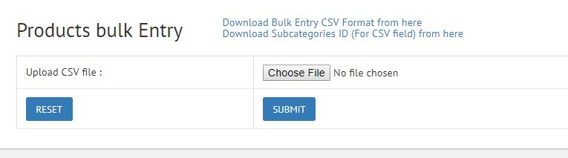

#### Description

This User Interface shows the form for uploading the excel sheet to add products into the database. The vendor will choose the CSV file and then, upload it. The products will be added. The format of CSV file and subcategories ID list will be available for download. The vendor can edit the CSV file and upload the same for addition of products.

### Individual entry for adding products

#### User Interface Design

Figure 42: Individual entry of products UI diagram

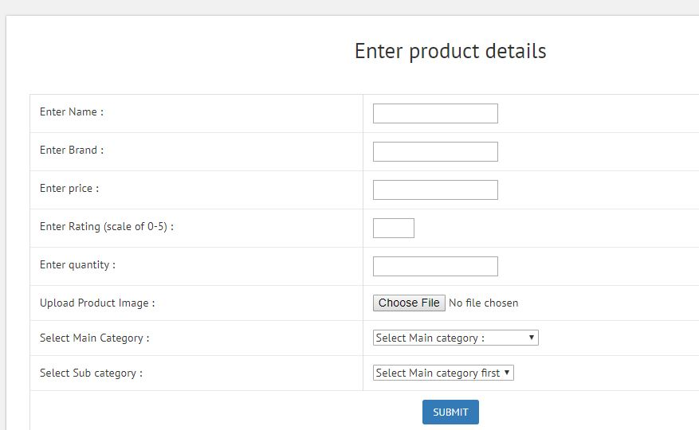

#### Description

This User Interface shows the form, that vendor will fill to add products into the database. The vendor will enter the product’s details into the form and then the system will validate the details. The details required are – product name, brand, quantity available, product rating. Then, user has to upload the image of the product. After that, user will select the main category of the product and then subcategory of the same. Then after submitting the form, product will be added to database.

### Edit/Delete products

#### User Interface Design

Figure 43: Edit/Update product UI diagram

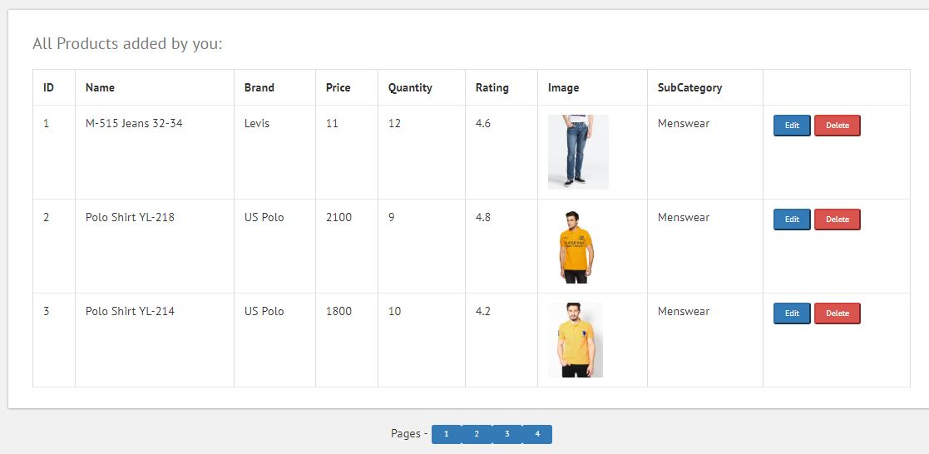

#### Description

This user interface shows the edit/delete product module of the vendor. Here, all the products of the vendor will be shown with pagination. If vendor has to update details of a particular product, then he will click the edit button corresponding to that product and then, update form will be opened. On clicking the delete button, the warning message will be displayed and then, on user confirmation, the product will be deleted from the database.

### Product update form

#### User Interface Design

Figure 44: Product Update form UI diagram

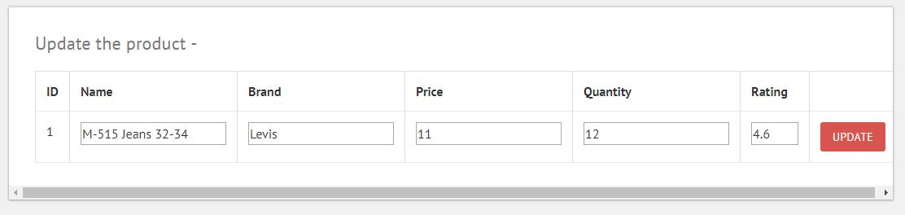

#### Description

This User Interface shows the form that will open when the vendor presses the edit button. After pressing the edit button, the original details will be visible to vendor and then, vendor will enter new details. After that, user will press the update button and details will be changed in database. But, the products already added in the cart should not be changed. Also, the vendor cannot change the product ID.

### Add images of incomplete entries

#### User Interface Design

Figure 45: Updating product images

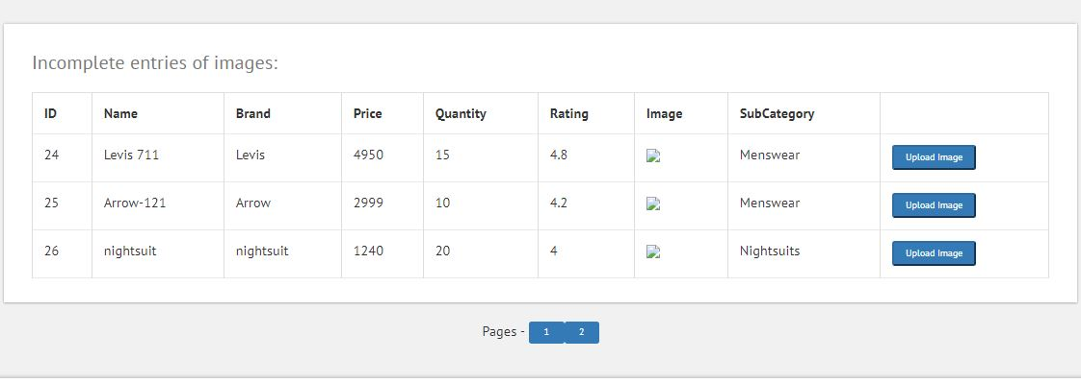

#### Description

This User Interface shows the image update module of vendor, in which the entries which are uploaded through excel sheet are displayed. The vendor will click the corresponding “Upload image” button and then, he will select the image file for the product. After uploading the image, the product will be disappeared from here and image will be visible on the customer side, where there was “Image not uploaded” earlier.

### Viewing order receipts

#### User Interface Design

Figure 46: Order receipt

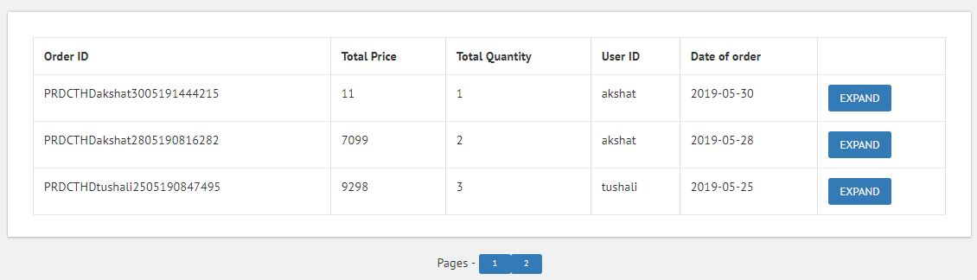

#### Description

This User Interface shows how the order receipts summary will be displayed. The vendor can view all the invoices and expand them to view the details of the orders. The vendor will view the details such as total price paid, total quantity, customer id, and date of order. There will be one expand button, which upon clicking, will open the details of the order.

### Expanded Order receipts

#### User Interface Design

Figure 47: Expanded Order receipt

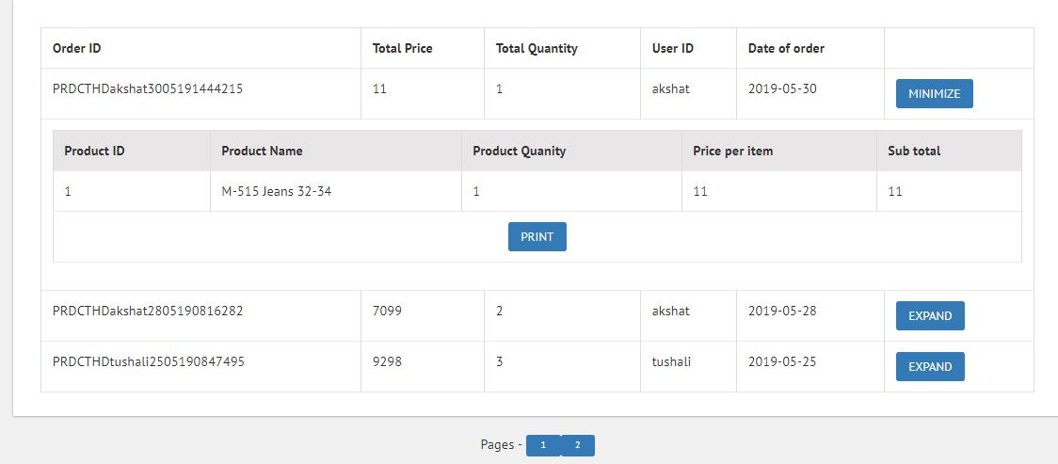

#### Description

This User Interface shows how the details will be displayed after the vendor has clicked the expand button of a particular order receipt. In the details, the product ID, product name, quantity, price and subtotal should be displayed. There will be a print button below, and if we click that, then the order details of that particular receipt will be printed, so that vendor can paste the printout at the time of delivering the item.

### Viewing all categories

#### User Interface Design

Figure 48: View all categories UI diagram

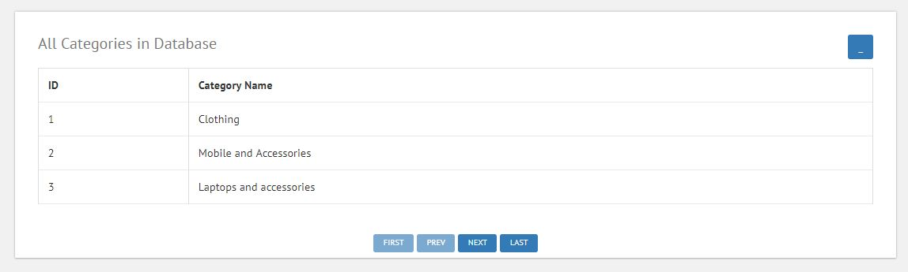

#### Description

This User Interface shows, how the administrator will view all the categories. At most 3 categories will be displayed and below that next, previous buttons will be there, which will used for page navigation.

### Viewing all subcategories

#### User Interface Design

Figure 49: Viewing all subcategories UI diagram

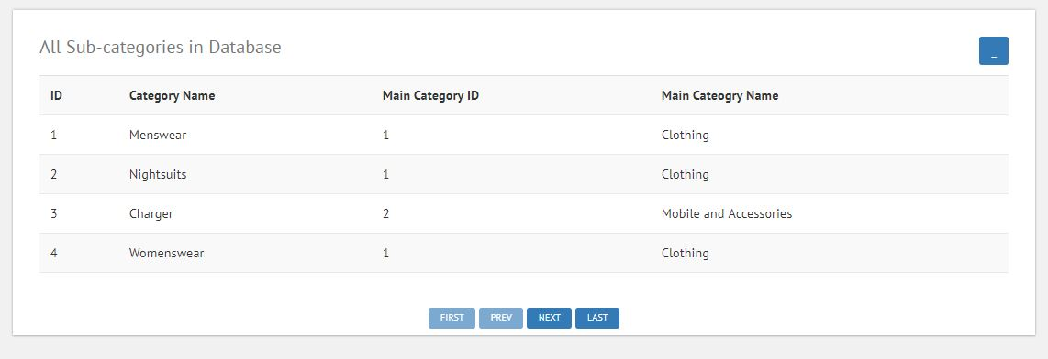

#### Description

This User Interface shows, how the administrator will view all the subcategories. At most 3 subcategories will be displayed and below that next, previous buttons will be there, which will used for page navigation.

### Adding main category

#### User Interface Design

Figure 50: Adding main category

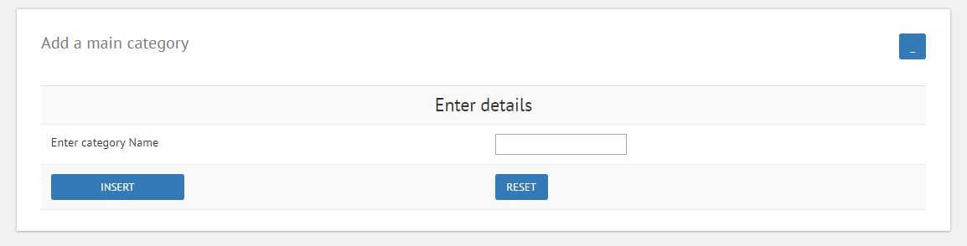

#### Description

This User Interface shows, how the administrator will add new main category to the database. The administrator will enter category name into the textbox and then, press the insert button. After that, the category will be added to the database.

### Adding subcategories

#### User Interface Design

Figure 51: Adding subcategories UI diagram

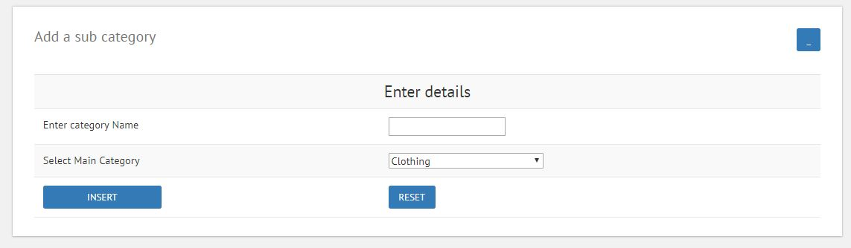

#### Description

This User Interface shows, how the administrator will add new sub category to the database. The administrator will enter subcategory name into the textbox and then select the main category. After that, the administrator will press the insert button. After that, the subcategory will be added to the database against the selected subcategory.

### User management page

#### User Interface Design

Figure 52: User management UI diagram

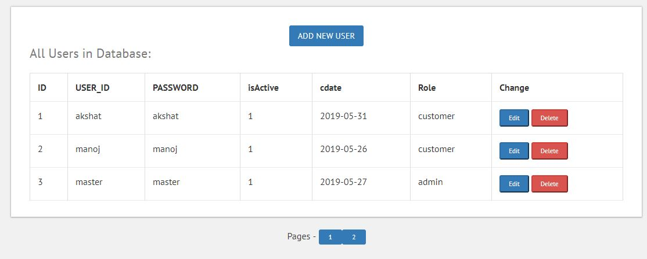

#### Description

This User Interface shows, how the administrator will manage all the users of the application. Above, there will be add new user button, and on clicking the button, the add user form will open. Also, there are edit and delete button, and when administrator clicks the edit button, an edit details form will open. On clicking the delete button, the corresponding user will be removed from the database and will no longer be able to use the application.

### Add new user form

#### User Interface Design

Figure 53: Add new user UI diagram

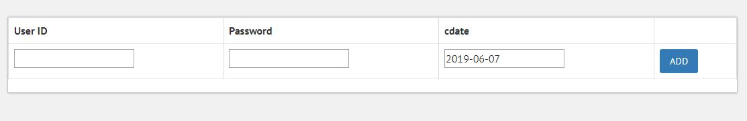

#### Description

This User Interface shows the form that will appear, when the administrator wants to add new users. Administrator will enter the user id and password in the input fields and then, user will be added to the database.

### Edit Details

#### User Interface Design

Figure 54: Edit User details UI diagram

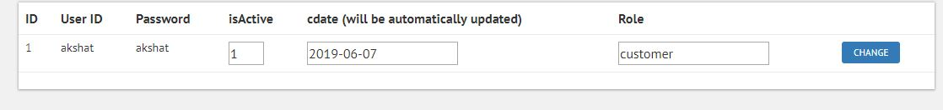

#### Description

This User Interface shows, how the administrator will edit the user information. After clicking the edit details button, the corresponding user’s details will open in the form and then, administrator can edit the details. After clicking the change button, details of that user will be updated in the database.

### User selection

#### User Interface Design

Figure 55: User Selection UI diagram

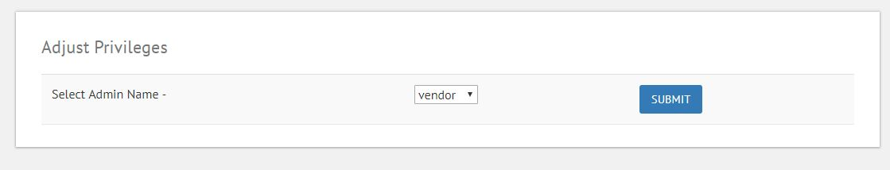

#### Description

This User Interface shows, how the administrator will select a vendor for adding, removing and adjusting the privileges. After the selecting the vendor, the administrator can perform the desired function of Access management.

### Adding privileges

#### User Interface Design

Figure 56: Adding privileges UI diagram

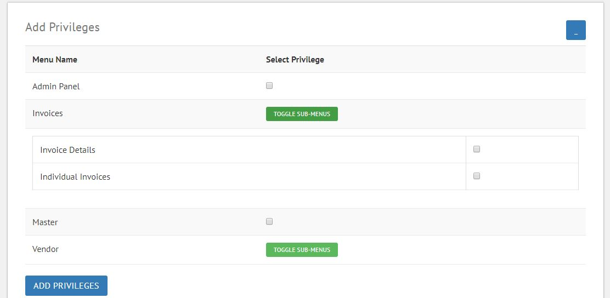

#### Description

This User Interface shows, how the administrator will add menu items or privileges for a vendor. The administrator will first select a vendor and this page will open, in which administrator will check the menu checkboxes, for which he want to make them available for the vendor. After selecting the menus, and clicking the “ADD PRIVILEGES” button, the menus will be added to database and will be available against and for the selected vendor.

### Delete privileges

#### User Interface Design

Figure 57: Removing privileges for vendor UI diagram

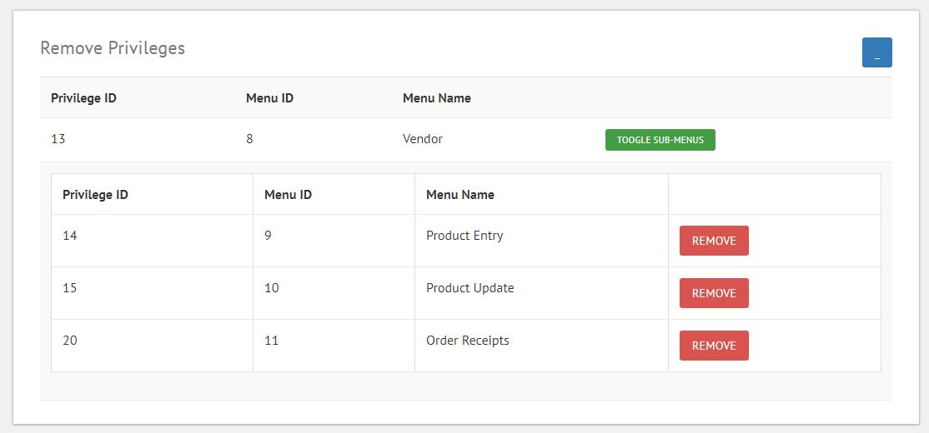

#### Description

This User Interface shows, how the administrator will remove the menus for the vendors. All the menus of the selected vendor will be displayed. Also, there will be one delete button, and after the administrator clicks the “REMOVE” button, the corresponding menu will be removed for the selected vendor.

### Viewing transactions

#### User Interface Design

Figure 58: Transactions view

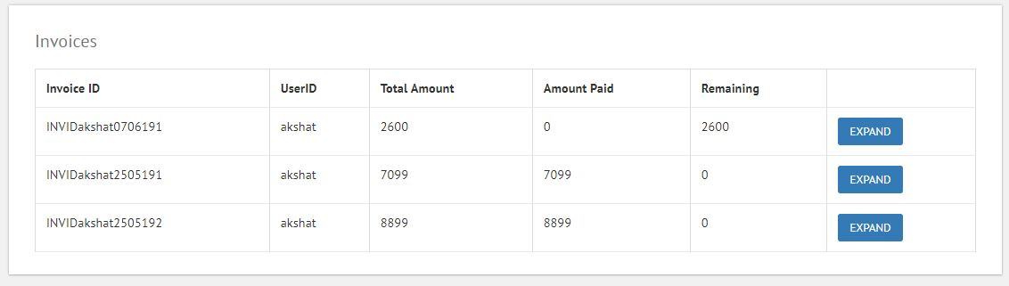

#### Description

This User Interface shows, how the administrator will view the transactions of the customers. There will be the invoice/bill id of the customer and against that, there will be the invoice summary, in which there will be User ID, total amount, amount paid and amount remaining to be paid. There is one expand button available against each invoice ID, and on clicking that, administrator will be able to view detailed information of that invoice.

### Expanded invoice details

#### User Interface Design

Figure 59: Expanded invoice details UI diagram

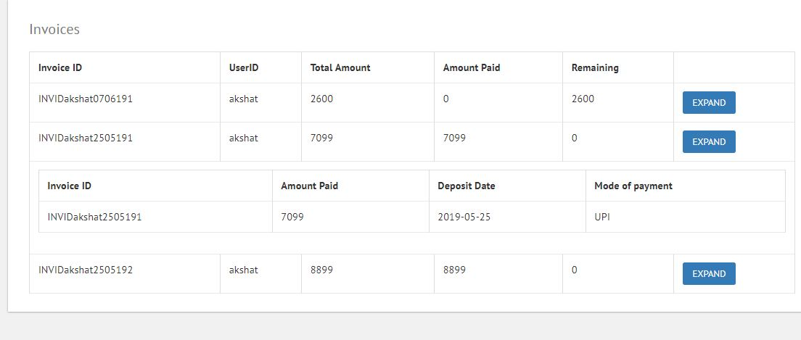

#### Description

This User Interface shows the expanded form of the invoices, which will appear when the administrator will press the expand button. The details which will appear are amount paid, date of deposit and mode of payment.

### Invoices of particular user

#### User Interface Design

Figure 60: Individual Invoices UI diagram

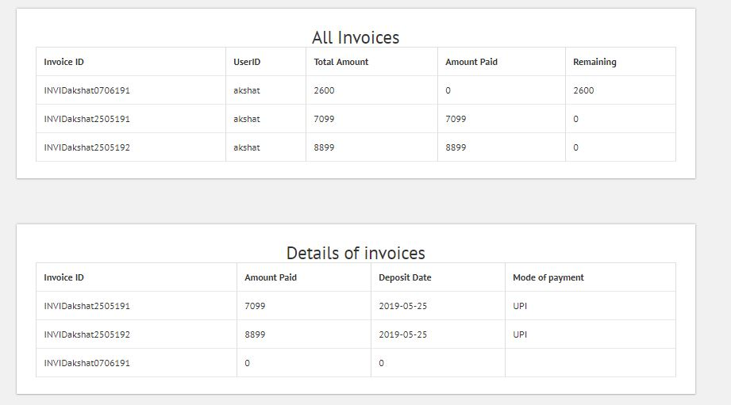

#### Description

This User Interface shows how the administrator can view the invoice details of a customer by his user ID. First, the administrator will select the user ID and then this screen will appear, which will have two sections. First section will contain the summary of all the invoices stored against the selected customer, which will contain User ID, total amount, amount paid, and amount remaining to be paid.

In the second section, the details of the invoices will be displayed in which there will be Invoice ID, amount paid, date of deposit, and mode of payment.

# Detailed Design

## Login/Signup Module

### Design

Figure 61: Login/Signup Class description

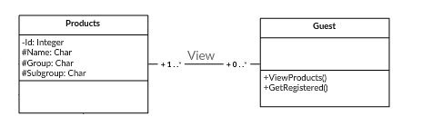

### Design Description

The above classes shows the relation between guest and application. The guest will view the products, but to add them to his/her cart, he has to get himself registered. For that, he has to sign up and then login using the required credentials.

## Purchasing products

### Design

Figure 62: Products Purchase Class description

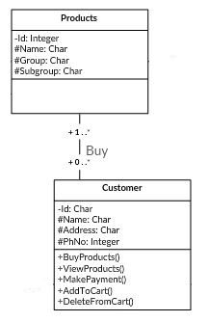

### Design Description

The above classes shows the relation between customer and products. The customer will view the products. After that, he will select the product and add it to his cart. He can change the quantity of the product before adding it. He can filter the products based on subcategories and brands.

## Adding products to cart

### Design

Figure 63: Customer’s Cart Class Description

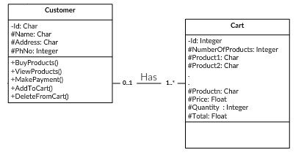

### Design Description

The above classes shows the relation between customer and his cart. The customer will buy products and before purchasing, all the products he will select, will be added to cart and then, he can view the details there. In the cart, he can change the quantity of the purchased products before buying them. He can also remove the items from his cart, if he wishes not to buy them. After that, if he has to buy products, then he can proceed to payment.

## Payment process

### Design

Figure 64: Login/Signup Class description

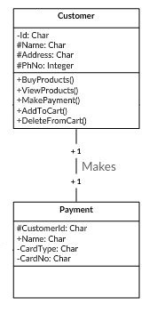

### Design Description

The above classes shows the relation between customer and payment process. After the cutomer has finalized his order and proceeds to pay for the order, the payment process has to be instanciated.

## Login/Signup Module

### Design

Figure 65: Login/Signup Class description



### Design Description

The above classes shows the relation between guest and application. The guest will view the products, but to add them to his/her cart. He have to get himself registered. For that, he has to sign up and then login using the required credentials.

## Login/Signup Module

### Design

Figure 66: Login/Signup Class description



### Design Description

The above classes shows the relation between guest and application. The guest will view the products, but to add them to his/her cart. He have to get himself registered. For that, he has to sign up and then login using the required credentials.

## Login/Signup Module

### Design

Figure 67: Login/Signup Class description



### Design Description

The above classes shows the relation between guest and application. The guest will view the products, but to add them to his/her cart. He have to get himself registered. For that, he has to sign up and then login using the required credentials.

## Login/Signup Module

### Design

Figure 68: Login/Signup Class description



### Design Description

The above classes shows the relation between guest and application. The guest will view the products, but to add them to his/her cart. He have to get himself registered. For that, he has to sign up and then login using the required credentials.

## Login/Signup Module

### Design

Figure 69: Login/Signup Class description



### Design Description

The above classes shows the relation between guest and application. The guest will view the products, but to add them to his/her cart. He have to get himself registered. For that, he has to sign up and then login using the required credentials.

# Appendix A – E-commerce web application class diagram

